**INFORMATION AND COMMUNICATION TECHNOLOGY**

**« ICT »**



# Introduction :

Our world today is witnessing rapid changes in the field of technology and digital transformation, leading to continuous development in how individuals and societies interact with information and technologies. Here, the importance of **Information and Communication Technology (ICT)** emerges as one of the main drivers of this evolution. Technology has become an integral part of our daily lives, influencing all aspects of life, from work and study to communication and entertainment.

The fast-paced digital world refers to an environment characterized by continuous innovation in areas such as computing, artificial intelligence, the internet, and communications, which heavily rely on ICT. This digital transformation, supported by **ICT** technologies, accelerates processes and changes lifestyles in unprecedented ways. Thanks to fast networks, smart devices, and cloud computing, individuals and organizations can access information and interact with the world instantly, enhancing productivity and creating new opportunities for innovation. So, what is the definition of **ICT**, what is its importance in today's world , What are the technologies related to ICT and What does the widespread use of ICT lead to ?

# The definition of ICT (Information and Communication Technology)

Information and Communication Technology (ICT) refers to the integration of various technological tools and resources that enable individuals and organizations to access, process, and communicate information. It encompasses hardware, software, telecommunications, and networking systems that work together to facilitate the efficient exchange of data across different platforms and devices. ICT is the backbone of modern digital society, supporting sectors like education, healthcare, government, and business by improving communication, enhancing data management, and fostering innovation.

# The Importance of Information and Communication Technology (ICT)

Information and Communication Technologies (TIC) have revolutionized various aspects of modern society, transforming how people interact, work, and access essential services.

|  |  |
| --- | --- |
| **Education** | - Facilitates access to knowledge and educational resources online. |
| - Supports remote learning and e-learning. |
| - Provides innovative educational tools such as interactive apps and virtual classrooms. |
| **Health** | - Improves healthcare through technologies such as telemedicine. |
| - Increases access to healthcare services in remote areas. |
| - Manages electronic medical records more accurately and easily. |
| **Economy** | - Enhances e-commerce and increases business opportunities online like Amazon, |
| - Improves business efficiency using information systems and smart management. |
| - Creates new job opportunities in the IT and software sector. |
| **Communications** | - Facilitates communication between individuals and institutions through email, instant messaging, and social platforms. |
| - Speeds up the transfer and exchange of information via digital networks. |
| **Government** | - Improves public services online, such as e-payment and digital authentication. |
| - Enhances transparency and civic participation through online platforms. |
| **Culture and Arts** | - Facilitates the sharing of artistic and cultural works online. |
| - Provides opportunities for artists and creators to reach a wider audience through digital media. |
| **Environment** | - Uses technology to monitor and protect the environment, such as smart systems for managing natural resources. |
| - Provides solutions to climate change, such as improving energy efficiency and using renewable energy sources. |
| **Security** | - Enhances digital security through protection systems and threat detection. |
| - Uses artificial intelligence in monitoring systems and analyzing data to detect cybercrimes. |

# Technologies related to Information and Communication Technology (ICT)

## Brief description of important TIC-related technologies

### Cloud Computing:

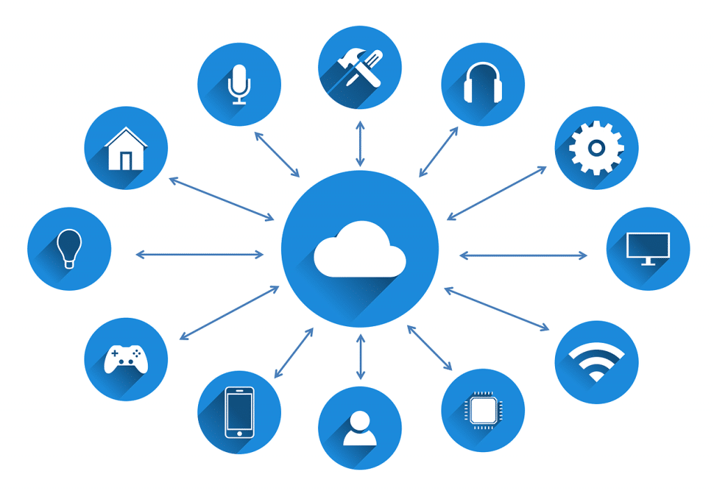

* Cloud Computing is a model for delivering computing services over the internet, where data is stored and software runs on remote (cloud) servers instead of local devices. This model allows users to access data, applications, and services online from any internet-connected device, without worrying about maintaining hardware or updating software.
* Key Uses:

1. **Cloud Storage:** Services like Google Drive and OneDrive allow users to store and access files from anywhere.
2. **Software as a Service (SaaS):** Platforms like Microsoft 365 and Google Workspace provide office tools online.
3. **Cloud Computing Services:** Providers like Amazon Web Services (AWS) and Microsoft Azure offer computing power and cloud resources for businesses and developers.

## Artificial Intelligence (AI):

* Artificial Intelligence is the ability of systems and software to mimic human cognitive abilities, such as learning, understanding, and decision-making, using algorithms and data. These systems can learn from past experiences and improve their performance over time, allowing them to interact intelligently with their environment and perform tasks that were previously considered exclusive to humans.
* Its Role:

1. **Improving Efficiency:** By automating repetitive tasks and reducing the need for human intervention.
2. **Prediction and Analysis:** Using AI to analyze big data and provide insights that help in making strategic decisions.
3. **Enhancing User Experience:** By offering personalized and real-time interactions through smart assistants and chatbots.
4. **Fostering Innovation:** Applying AI across various industries to develop new technologies and solutions such as self-driving cars, medical AI, and drones.

## Networking:



* Networking refers to the practice of connecting computers, devices, and systems to share resources and communicate with each other. It enables the transfer of data and information across various platforms, both within local environments (like a home or office) and globally (like the internet).
* Key Aspects of Networking:

1. **Local Area Network (LAN):** A network that connects devices within a limited area, such as a building or campus, allowing for the sharing of resources like printers and files.
2. **Wide Area Network (WAN):** A network that covers a larger geographical area, such as cities, countries, or even continents, connecting LANs and allowing global communication and data transfer.
3. **Wireless Networks:** Networks that do not require physical cables to connect devices, such as Wi-Fi, which uses radio waves to transmit data.
4. **Internet:** A global network of networks that connects millions of private, public, academic, business, and government devices, enabling communication and access to a vast array of services and information.
5. **5G Networks:** The fifth generation of mobile network technology, offering significantly higher speeds, lower latency, and more reliable connections for mobile devices and IoT (Internet of Things).
6. **Virtual Private Network (VPN):** A secure, private network that allows users to send data over the internet as if they were on a private network, providing encryption and privacy for online activities.

## GOOGLE SERVICES

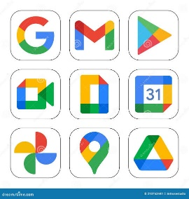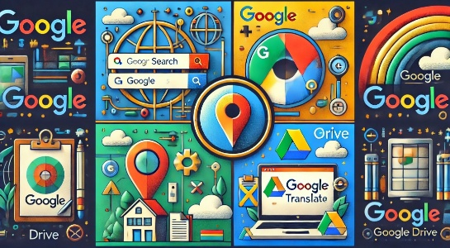

**1. Definition :**

A Suite of Tools for a Connected World

Google has become synonymous with the internet, and its suite of services plays a pivotal role in our daily lives. From the moment we wake up to the moment we go to bed, Google services are likely involved in some capacity. This essay will explore some of the most popular Google services and their impact on individuals and businesses.

**2. The Core Services:**

Search,Gmail,and Maps Undoubtedly. Google Search is the cornerstone of Google's empire. It has revolutionized how we find information, making knowledge readily accessible with a few keystrokes. Gmail, Google's email service, has become the de facto standard for personal and professional communication, offering features like spam filtering and large storage capacities. Google Maps has transformed navigation and exploration, providing detailed maps, real-time traffic updates, and even public transportation information.

**3. Productivity and Collaboration: Tools**

Google Workspace, formerly known as G Suite, offers a range of productivity tools that have streamlined workflows for individuals and businesses alike. Google Docs, Sheets, and Slides enable real-time collaboration on documents, spreadsheets, and presentations, making it easier for teams to work together remotely. Google Meet facilitates video conferencing, allowing for virtual meetings and presentations. Google Drive provides cloud storage and file synchronization, ensuring that files are accessible from anywhere.

Beyond the Essentials: Entertainment and Innovation.

Google's reach extends beyond productivity and communication. YouTube, the world's largest video-sharing platform, offers a vast library of videos on virtually any topic imaginable. Google Play Store provides access to a wide range of apps, games, and books for Android devices. Google Assistant, a voice-activated virtual assistant, helps users with tasks like setting reminders, playing music, and answering questions.

**4. The Impact of Google Services:**

Google services have had a profound impact on society. They have empowered individuals with access to information, facilitated communication and collaboration, and transformed how we work, learn, and entertain ourselves. However, the dominance of Google also raises concerns about privacy, data security, and competition.

**5.The Future of Google Services:**

As technology continues to evolve, Google is likely to remain at the forefront of innovation. The company is investing heavily in areas such as artificial intelligence, machine learning, and augmented reality. These technologies will likely shape the future of Google services, making them even more integrated into our lives

**In conclusion**, Google services have become an integral part of our digital lives. They offer a range of tools that empower individuals and businesses, making it easier to connect, collaborate, and achieve our goals. While concerns about privacy and competition remain, Google's commitment to innovation ensures that its services will continue to evolve and shape the future of technology.

If you would like, I can expand on any of the sections above or provide additional information on specific Google services.

**Example Use Case**: How Google Docs Enhances Team Collaboration

Imagine a team of writers working on a marketing campaign. Traditionally, they might have to share drafts via email, leading to version control issues and potential confusion. With Google Docs, however, the team can work on the same document simultaneously. Each member can see the changes made by others in real-time, allowing for seamless collaboration and discussion. This eliminates the need for multiple versions and ensures that everyone is working with the most up-to-date information.

Additional Information on Specific Google Services

* Google Drive: Cloud storage service that allows users to store files online and access them from any device with an internet connection. Drive also offers features like file sharing, collaboration, and version history.

* Google Meet: Video conferencing service that allows users to hold meetings with up to 250 participants. Meet offers features like screen sharing, recording, and background blur.

* Google Assistant: Voice-activated virtual assistant that can be used to set reminders, play music, answer questions, and control smart home devices

## Microsoft Tools in Information and Communication Technologies (ICT):

Microsoft offers a wide range of tools and services that are integral to TIC. These tools are designed to enhance productivity, collaboration, and communication in both personal and professional settings. Below are the key Microsoft tools:

1. Microsoft office suite: The Microsoft Office Suite is one of the most widely used productivity tools globally applications

* Microsoft Word: For creating and editing documents.
* Microsoft Excel: For data analysis, spreadsheets, and financial calculations.
* Microsoft Power point: For creating professional presentations.
* Features:
* Templates for quick content creation.
* Advanced formatting and editing options
* Integration with OneDrive for cloud storage and collaboration

1. Microsoft Teams: A platform for communication and collaboration, especially popular in remote work and education.

* Features:
* Video conferencing and virtual meetings.
* Instant messaging and group chats.
* File sharing and real-time collaboration on documents.

1. Microsoft OneDrive: A cloud storage service that ensures secure file storage and access from anywhere.

* Features:
* .5GB of free storage, with paid plans for more capacity.
* Automatic syncing of files across devices and Real-time collaboration with Microsoft 365 apps.

1. Microsoft Azure: A cloud computing platform that offers a wide range of services, for example companies use Azure to host websites, manage databases, and analyze big data
2. Microsoft Outlook: An email and calendar management tool that Helps in organizing meetings and tracking deadlines
3. Microsoft SharePoint: A web-based platform for content management and collaboration.

* Features:
* Centralized document storage.
* Workflow automation and task management.
* Customizable team sites for projects

1. Microsoft Edge: A modern web browser designed for productivity used by students for research and organizing academic resources

## Version Control: Git and GitHub:

* You Should Know About Git: What it is? and How it Works in Software Development?
* Definition of Git: Git is a "distributed version control system" (VCS) that allows developers to track and manage changes to their codebase, over time. It enables several programmers to work on the project together, by keeping history of changes to files; and supporting branching and merging so that the development team can go back to previous versions of the project if needed. Git allows each user to have a standalone copy of the entire repository instead of just the current version of files, unlike version control systems that are centralized.
* How Git Works: It organizes project file snapshots in a more incremental way. These snapshots preserve the state of the project at different moments in time. Here’s a rundown of the fundamentals:
* 2-1) Key Git Concepts
* Repository (Repo): A repo is a folder that contains all of the project files, the entire commit history, and all of the versioning data. It can be local (in your computer) or remote (in platforms such as GitHub or GitLab).
* Commit: Like a snapshot of the project at a particular point in time. Each commit includes:
* The changes made.
* A unique identifier (hash).
* A commit message explaining the change.
* Pointing to the parent commit (except for the first commit).
* Branch: You can create an independent branch to work with a version of the project. The primary branch is usually named main or master, but other branches can be created for new features, bug fixes, etc. This separation means that developers can work on features while the swagger for the stable version of the code is unaffected.
* Step 2: Staging Area (Index): Files are added to the staging area before committing. This is where modifications are staged before committing them
* Working Directory: This is the local directory where the actual files are stored. Files which have had changes made to them are not being tracked by Git until they are added to the staging area.
* 2-2) Git Workflow:
* Here are the typical steps involved in your general workflow with Git:

1. Clone a Repository: If you are working on a pre-existing project, you clone the repository from some remote source (like GitHub) to your local machine using:

* git clone

1. Push Changes to a Remote Repository:

Locally the changes are committed and then pushed to a remote repository (e g GitHub) using:

* git push origin

1. Fetching Changes from a Remote Repo:

To see if anyone else has changed the remote repository, use:

* git pull origin
* Importance of Git in Software Development: Git is very vital in the current software development and the role of Git cannot be overemphasized. Here are the key reasons why Git is essential:
* Collaboration: Git makes it possible for multiple developers to work on the same project at the same time without one developer’s changes affecting the others negatively. By means of branches every developer is able to develop new features as well as to fix bugs. Git makes it easier to deal with the merging of these changes to the master branch. developers can pull or merge requests to check and comment on the changes to be incorporated into the project.
* Version Control: Everyone who uses Git can see the changes that have been made to the codebase over time. That is, if there is a mistake, one can go back to a previous version of the program or undo certain changes through the checkout command when using Git This version control also enables developers to maintain different versions of the project (e.g. production, development, experimental) using different branches.
* Code Integrity and Quality: Git assists in preserving the historical accuracy of the project's source code by documenting all changes made to the source. If a bug is detected, Git can help a developer to track down the point in time that this bug was created and which amendments introduce it. This is achieved by evaluating various commits and examining what was altered between the two images as a result of the deviation.
* Backup and Security: Every developer is able to retrieve deleted files as a result of Git's distributed nature because every developer has a complete copy of the project on their machine. Moreover, the project can be stored on services such as GitHub or GitLab and this is already an additional safe and offsite backup which prevents loss of important data.
* Branching and Feature Isolation: With Git comes the ability to branch out and work on separate bits and pieces of the main code so certain aspects can be isolated. New features or bugs can be added or fixed respectively without impacting the entire pre-existing code base. And once that new bit is complete, it can simply be snapped back to the main working area of the code.
* Continuous Integration and Deployment (CI/CD): When there is a constant flow of new codes being integrated with existing ones, Git serves as one of the key components of the process. When such sudden changes occur to a code repository, Git is the feature that runs a bunch of automated tests and pushes the amended codes. There are multiple apps such as GitHub Actions, GitLab CI and Jenkins that when integrated with Git support automatic testing that in turn boosts productivity.
* Code Review and Collaboration: Synchronizing Git. Now that we have finished the integration of students’ repositories into the sister’s appropriate repositories, let us now take a moment to consolidate the knowledge we have acquired in this lesson. GitHub, GitLab
* GitHub
* Definition of GitHub: GitHub is a popular multi-faceted purpose of securing repositories, code collaboration, and opensource projects contribution.

A three-dimensional view of these three elements is as follows:

1. Securing Repositories

* Version Control: To start with, repositories on GitHub are hosted using Git, which is a distributed version control system. This effectively means that once a developer's code is kept in a repository, it will be possible to monitor and control any alterations made on that code, even to the extent of restoring previous versions if need be.
* Private and Public Repositories: Another type of repository that can be created on GitHub is Private repositories which are retained and viewable only by the owner of the repository and, some selected collaborators, and a public repository which any person can have access to.
* Storage and Access: GitHub is said to be a cloud-based facility. Hence it is possible to access it from anywhere, making it easy to secure repository code and related documents, images amongst others.

1. Code Development

* Branches: Another structural form of protection of that code is through branches, whereby developers create branches or offshoots that allow them to create new features or fix bugs without impacting on the main code or the baseline version, which in most case is referred to as the main or master branch.
* Pull Requests (PRs): In a situation when there are no improvements, the developer then proposes merging that branch into the initial one. That begins the procedure in which other potential team members can offer their feedback with suggestions concerning that change as well as endorse (or disallow) the modification.
* Issues and Projects: In addition, where developmental efforts are made, an issue tracking knitting helmet is integrated in GitHub.
* Issues and Tasks: Issues Tracker in the Git hub Sites supports the issue tracking where the developers can post tasks, bugs or feature requests with the aim of creating new things. The Contributions section essentially aids in the collations and monitoring of effort expended.
* Workflows and Integrations: With GitHub Actions users can automate several processes like CI/CD and many more directly in the platform.
* Pull Requests: The process of code reviews is facilitated by GitHub where people in the same team review each other’s code before it is merged into the main branch. For specific changes made on the lines of code, inline comments can also be added.
* Forking: Basically, to be able to participate in an open-source project, developers will have to fork the repository allowing them to make their own copy of the project. In case developers decide to make some changes, they will be able to send a contributing request afterwards allowing them to propose the changes to the parent repository.
* Contributing Guidelines: There are open-source projects which utilize the ‘CONTRIBUTING.md’ document to explain in details how contributors can participate in the project. This will most likely ensure uniformity and order in many contributions.
* Star and Watch Repositories: The users ‘star’ repositories they wish to favorite and ‘watch’ them if they want to get notification regarding activities like issues and pull requests that occur on the repository.
* Community and Discussion: GitHub provides the facilities for an active community, with discussion board options available for contributors and maintainers to discuss topics on the project.
* Licensing: Most open-source projects on GitHub use widely spread licensing like MIT, GPL, or Apache, which specify what can be done with the code: use, modification, or redistribution.
* The Key Features of Open Source and Collaboration Are:
* GitHub Pages: Static website hosting for personal portfolios or even project documentation is possible right from a repository.
* GitHub Sponsors: Allow users to financially support open-source developers and projects.
* Contributions Graph: GitHub keeps track of your contributions over time, showing your activity such as issues reported, pull requests merged, and code commits.

All these features combined, GitHub has become the de facto standard for software development, collaboration, and Opensource contribution.

* The flowchart:

Start (Git Repo)

Working Directory

(Modified or Untracked)

Stage Changes (git add)

(Staging Area)

Commit Changes (git commit)

(Local Repository)

Commit Tree

(Commit History)

Push Changes (git push)

(Remote Repository)

Pull Changes (git pull)

(Sync with Remote)

End

.

This flow shows how Git keeps track of changes in code through its stages: working directory, staging area, local commits, and remote repositories.

**COMPARISON TABLE OF ICT TOOLS**:

ICT TOOLS FEATURES

|  |  |
| --- | --- |
| **1. Word** | Document Processing Creating and formatting text documents Text editing, formatting, spell check, grammar check, image insertion User-friendly interface, wide range of formatting options Can be resource-intensive for complex documents | Reports, essays, letters, resumes, basic brochures |
| **2. Excel** | Spreadsheet Software Organizing and analyzing data Spreadsheets, formulas, charts, data visualization, pivot tables Powerful data analysis capabilities, excellent for calculations and data manipulation Can have a steep learning curve for complex functions financial modeling, data analysis, budgeting, tracking, creating charts and graphs |
| **3. PowerPoint** | Presentation Software Creating visual presentations Slides, images, videos, animations, transitions, speaker notes Engaging visual presentations, easy to share and collaborate Can be template-driven, may encourage overly simplistic presentations Business presentations, educational lectures, marketing campaigns |
| **4. LaTeX** | Typesetting System Creating high-quality documents, especially for scientific and technical content Precise control over typography, complex mathematical equations, bibliographies Superior for complex layouts and mathematical notation Steeper learning curve than Word requires more technical knowledge Scientific papers, books, theses, technical documentation |
| **5. HTML & CSS** | Web Development Creating the structure and style of web pages HTML defines the content and structure, CSS controls the visual presentation Foundation of web development, versatile for creating custom designs Requires knowledge of coding principles, can have a steeper learning curve Building websites, web applications, front-end development |
| **6. Git** | Version Control System Tracking changes to code, collaborating on projects Branching, merging, committing, reverting to previous versions Essential for software development, enables collaboration and reduces errors Can have a steeper learning curve initially, requires understanding of command-line interface Software development, collaborative projects, managing code changes |
| **7. GitHub** | Code Hosting Platform Hosting and sharing code, collaborating on projects Online platform for Git repositories, issue tracking, project managemen community features large community, excellent for open-source projects, facilitates collaboration Requires internet access, can have a steeper learning curve for beginners Open-source projects, collaborative software development, hosting code repositories |
| **8. Google Services** | (Docs, Sheets, Slides, Meet, Drive): Suite of Online Productivity Tools Document creation, data analysis, presentations, video conferencing, file storage Cloud-based, real-time collaboration, accessibility from anywhere with internet, integration with other Google srvices Collaborative features, accessibility, cost-effective Requires internet connection, reliance on Google's infrastructure Collaborative work, online learning, remote work, file sharing, online meetings |

# The widespread use of ICT (Information and Communication Technology) presents several new challenges in today's world:

1. Privacy Problems: People worry about how their personal data is collected and used without permission.
2. Cybersecurity Risks: Hacking, viruses, and online attacks can cause big problems for businesses and individuals.
3. Unequal Access: Not everyone has the same access to technology, especially in poor or rural areas.
4. Over-dependence: If technology fails, many systems like banking, healthcare, or communication can stop working.
5. Fake News: False information spreads quickly online and confuses people.
6. Environmental Issues: Making and throwing away tech devices harms the environment and uses a lot of energy.
7. Mental Health: Spending too much time online can lead to stress, loneliness, or addiction.
8. Difficult to Control: Governments struggle to make rules to manage technology use safely.
9. Cultural Impact: Local cultures and languages might be lost because global platforms dominate.

These challenges mean we need to use ICT carefully and responsibly.

# Conclusion :

In conclusion, discussing Information and Communication Technology (ICT) highlights its profound impact on all aspects of our daily lives. From facilitating economic processes and improving healthcare and education services to enhancing communication among individuals and organizations worldwide, ICT continues to shape our modern world. This ongoing advancement presents a tremendous opportunity to improve quality of life and achieve sustainable development. However, it also poses challenges related to digital security and technology governance. Therefore, we must harness this field wisely by adopting strategies that promote innovation and ethical responsibility to ensure a bright future where technology serves as a fundamental driver of progress and prosperity.

# In addition:

* what is the difference between ICT and computer science

|  |  |
| --- | --- |
| 1. ITC | 2. computer science : |
| * Scope: ICT refers to the tools and technologies used to handle and disseminate information. It includes the infrastructure, devices, and systems used for communication. * Examples: Internet, smartphones, social media platforms, video conferencing tools, and broadcasting technologies. * Emphasis on communication, information sharing, and the integration of technology in fields like education, business, and media. * Objective: Facilitating communication and access to information for broader societal benefits. | * Scope: computer science focuses the study of computing systems, algorithms, programming, and data management. * Examples: Software development, database management, artificial intelligence, cybersecurity, and operating systems. * Developing and optimizing software and hardware solutions. * Objective: Solving technical problems and advancing computing technologies. |

Key Difference:

ICT is more about using technology to enable communication and share information, while computer science is about creating and understanding the underlying technologies and systems that make such communication possible.